**Practical No: - 6**

**Aim:Create a fuzzy logic system for Air conditioner using MATLAB.**

**PROBLEM SUMMARY:**

The task of dehumidification and temperature decrease goes hand in hand in case of conventional AC. Once target temperature is reached AC seizes to function like a dehumidifier. Also complex interactions between user preferences, actual room temperature and humidity level are very difficult to model mathematically. But in this work this limitation has been taken into cogitation and overcome to a great extent using fuzzy logic to represent the intricate influences of all these parameters. The optimal limits of comfort zone, typically marked at a temperature of 25°C and dew point 11°C, are used as the targets. Conventional AC system controls humidity in its own way without giving the users any scope for changing the set point for the targeted humidity unlike the scope it offers to change the set point for the targeted temperature through a thermostat. This causes a significant level of flexibility as well as efficiency loss especially in hot and humid countries like India. For instance at higher humidity level (say at dew point 18°C) an occupant may perceive same comfort level at 22ºC as he would perceive at 26ºC at dew point 15°C. This translates to huge energy and monitory saving in terms of reduced compressor/fan duty cycle. In the developed scheme, the sensor captured temperature, user temperature preference and humidity readings are fuzzified. These are used to decide the fuzzy qualifier, which is decoded into a crisp value that in turn controls different aspects of the AC. In the problem dew point (Td) temperature is used to measure humidity instead of relative humidity (RH), this is because RH is a function of both temperature and moisture content while Td is a function of moisture content only. Hence it becomes very easy to model comfort level on the basis of Td. Human reaction to different levels of dew point



**INTRODUCTION TO AIR CONDITIONER’S WORKING :**

Air conditioners use refrigeration to chill indoor air, taking advantage of a remarkable physical law: When a [liquid](http://science.howstuffworks.com/liquid-info.htm) converts to a [gas](http://science.howstuffworks.com/gas-substance-info.htm) (in a process called **phase conversion**), it absorbs heat. Air conditioners exploit this feature of phase conversion by forcing special chemical compounds to evaporate and condense over and over again in a closed system of coils.

The compounds involved are **refrigerants** that have properties enabling them to change at relatively low temperatures. Air conditioners also contain fans that move warm interior air over these cold, refrigerant-filled coils. In fact, central air conditioners have a whole system of ducts designed to funnel air to and from these serpentine, air-chilling coils.

When hot air flows over the cold, low-pressure **evaporator coils**, the refrigerant inside absorbs heat as it changes from a liquid to a gaseous state. To keep cooling efficiently, the air conditioner has to convert the refrigerant gas back to a liquid again. To do that, a compressor puts the gas under high pressure, a process that creates unwanted heat. All the extra heat created by compressing the gas is then evacuated to the outdoors with the help of a second set of coils called **condenser coils**, and a second fan. As the gas cools, it changes back to a liquid, and the process starts all over again. Think of it as an endless, elegant cycle: liquid refrigerant, phase conversion to a gas/ heat absorption, compression and phase transition back to a liquid again.

It's easy to see that there are two distinct things going on in an air conditioner. Refrigerant is chilling the indoor air, and the resulting gas is being continually compressed and cooled for conversion back to a liquid again. On the next page, we'll look at how the different parts of an air conditioner work to make all that possible.

**The Parts of an Air Conditioner**

Let's get some housekeeping topics out of the way before we tackle the unique components that make up a standard air conditioner. The biggest job an air conditioner has to do is to cool the indoor air. That's not all it does, though. Air conditioners monitor and regulate the air temperature via a thermostat. They also have an onboard filter that removes airborne particulates from the circulating air. Air conditioners function as dehumidifiers. Because temperature is a key component of relative humidity, reducing the temperature of a volume of humid air causes it to release a portion of its moisture. That's why there are drains and moisture-collecting pans near or attached to air conditioners, and why air conditioners discharge water when they operate on humid days. Still, the major parts of an air conditioner manage refrigerant and move air in two directions: indoors and outside:

* 1. **Evaporator -** Receives the liquid refrigerant
  2. **Condenser -** Facilitates heat transfer
  3. **Expansion valve -** regulates refrigerant flow into the evaporator
  4. **Compressor -** A pump that pressurizes refrigerant

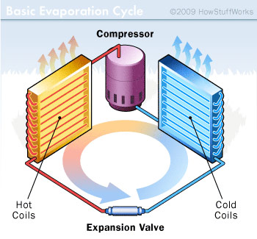

The cold side of an air conditioner contains the evaporator and a fan that blows air over the chilled coils and into the room. The hot side contains the compressor, condenser and another fan to vent hot air coming off the compressed refrigerant to the outdoors. In between the two sets of coils, there's an **expansion valve**. It regulates the amount of compressed liquid refrigerant moving into the evaporator. Once in the evaporator, the refrigerant experiences a pressure drop, expands and changes back into a gas. The **compressor** is actually a large electric pump that pressurizes the refrigerant gas as part of the process of turning it back into a liquid. There are some additional sensors, timers and valves, but the evaporator, compressor, condenser and expansion valve are the main components of an air conditioner.

Although this is a conventional setup for an air conditioner, there are a couple of variations you should know about. Window air conditioners have all these components mounted into a relatively small metal box that installs into a window opening. The hot air vents from the back of the unit, while the condenser coils and a fan cool and re-circulate indoor air. Bigger air conditioners work a little differently: Central air conditioners share a control thermostat with a home's heating system, and the compressor and condenser, the hot side of the unit, isn't even in the house. It's in a separate all-weather housing outdoors. In very large buildings, like hotels and hospitals, the exterior condensing unit is often mounted somewhere on the roof.

**STEPS TO IMPLEMENT FIS FOR AIR CONDITIONER IN MATLAB :**

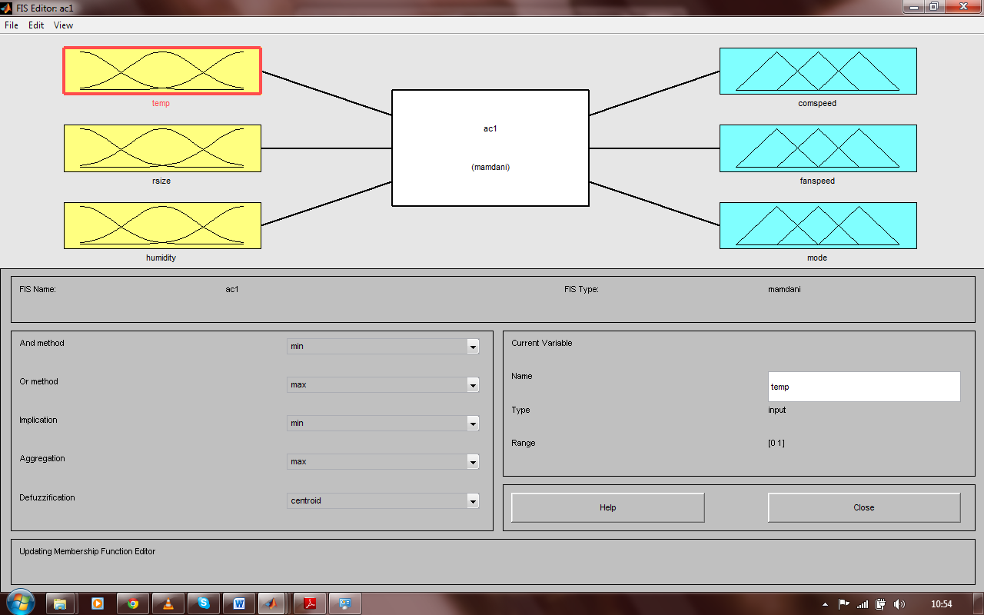

1. **Select the no of inputs :** in air conditioner system we have taken three inputs. The three inputs are as following :

Temperature

Room size

Humidity

1. **Membership functions for all inputs and its linguistic variables :**

Temperature (0 to 50 degree celcius) :

|  |  |
| --- | --- |
| **Linguistic variables** | **Membership function** |
| Cold | Trapmf |
| Cool | Trimmf |
| Pleasant | Trimmf |
| Warm | Trimmf |
| Hot | Trapmf |

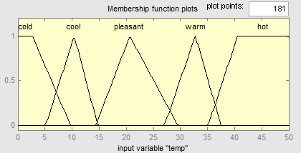

Room size (0 to 3000 square feet) :

|  |  |
| --- | --- |
| Linguistic variable | Membership function |
| Small | Trapmf |
| Medium | Trapmf |
| Large | Trapmf |

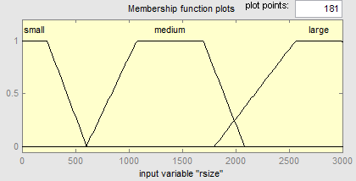

Humidity (0 to 30 grams per cubic meter) :

|  |  |
| --- | --- |
| **Linguistic variable** | **Membership function** |
| Optimal | Trapmf |
| Humid | Trapmf |

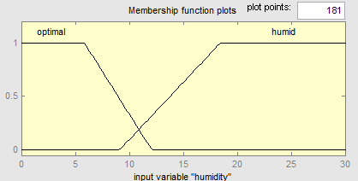

1. **Select the no of output :** in this system the no of outputs are three as following :

Compressor speed

Fan speed

Mode

1. **Membership functions for all outputs and its linguistic variables :**

Compressor speed (0 to 60 rotation par minute) :

|  |  |
| --- | --- |
| **Linguistic variables** | **Membership function** |
| Off | Trimmf |
| Low | Gaussmf |
| Medium | Gaussmf |
| Fast | Trapmf |

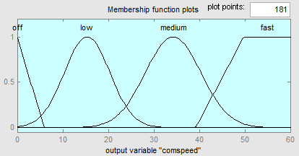

fan speed :

|  |  |
| --- | --- |
| Linguistic variables | Membership function |
| Off | Trimmf |
| Low | Gaussmf |
| Medium | Gaussmf |
| Fast | Trapmf |

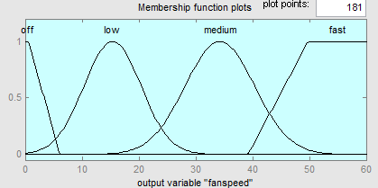

Mode :

|  |  |
| --- | --- |
| **Linguistic variables** | **Membership function** |
| Dehumidifier | Trapmf |
| Ac | Trapmf |

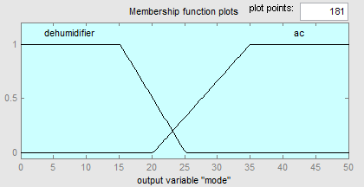

1. **Rules for air conditioner FIS system :**

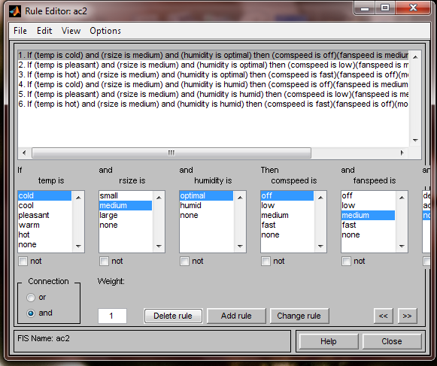

1. **Output of rules in rule viewer :**In this screen shot the inputs are temperature is hot room size is medium and humidity is optimal the n the output of compressor speed is fast fan speed is off and mode is AC. this output is based on six rules defined in the FIS.

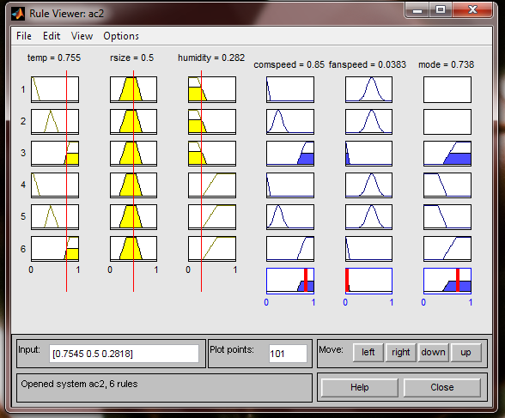

**In this FIS system:**

**Implication method is: Min**

**Aggregation method is: Max**

**Defuzzification method is: Centroid**

**Air Conditioner that uses Fuzzy inference system:**

an industrial air conditioner designed by Mitsubishi uses 25 heating rules and 25 cooling rules. A temperature sensor provides input, with control outputs fed to an inverter, a compressor valve, and a fan motor. Compared to the previous design, the fuzzy controller heats and cools five times faster, reduces power consumption by 24%, increases temperature stability by a factor of two, and uses fewer sensors.

**Real life example Mitsubishi air conditioner:**Example: Air-conditioning System by Mitsubishi

**Problem description:**Industrial air-conditioning system that shall be able to react flexibly to changing ambient conditions

**Realization:**

* 50 rules
* 6 linguistic variables
* Resolution: 8 bit
* Input variables: room temperature, wall temperature and temporal evaluation of this signals

**Development:**

* 4 days to create the prototype
* 20 days for testing and integration
* 80 days for optimization with real test objects
* Implementation as pure software solution on standard microcontroller

**Results:**

* Reduction of starting processes down to 40 percent of the standard solution
* Sustaining of the temperature even with interference factors (like open window, etc.) substantially improved
* Fewer sensors required
* Established energy saving by testing: 24 percent

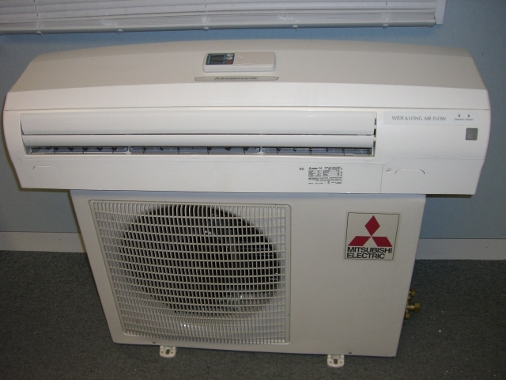

**Future directions :**

The paper simplified the problem by not allowing AC to reverse operation and act like a heat pump and humidifier. By eliminating these restrictions we can go for an all weather AC that would work in almost any part of the world. Also by adding infra red sensors to detect presence of occupants we can go one step ahead in user satisfaction. These sensors can aggregate data such as occupant location and body temperature. These data can further help control temperature, humidity and fin direction automatically for maximum comfort while reducing energy consumption. Application of neural networks and genetic algorithm will allow the controller to adapt to individual user, room environment and weather. An AC that will be “intelligent” in true sense!